Chapter 4, Problem 32.

Use source transformation to find i_{x} in the circuit of Fig. 4.100.

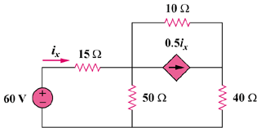

Figure 4.100
For Prob. 4.32.

